Third Street Church

August 11, 2024

Prelude & Lighting of the Candles

Welcome and Announcements

*Call to Worship - Please stand as indicated by the (*) and respond in unison
by the bold type.

*Liturgy Psalm 121

L - I lift up my eyes to the hills where does my help come from?
All - My help comes from the Lord, the Maker of heaven and earth.

L - He will not let your foot slip he who watches over you will not slumber;
All - indeed, he who watches over Israel will neither slumber nor sleep.

L - The Lord watches over you the Lord is your shade at your right hand;
All - the sun will not harm you by day, nor the moon by night.

L - The Lord will keep you from all harm he will watch over your life;
All - the Lord will watch over your coming and going both now and forevermore.

*Worship Song (Hymnal) #369 “Blessed Assurance”
(Insert) “King of Kings”

Scripture Reading: Colossians 4:2-6

Family Prayer Time

Offering

*Doxology #95 “Praise God, from Whom All Blessings Flow”

*The Lord’s Prayer

*Worship Song
(Insert) “Behold Our God”

Message: “Prayers for the Early Church” – Colossians 4:2-6

*Worship Song (Insert) “Great are You Lord”

*Benediction from Pews
#666 “Shalom to You”
(Hold hands in a circle around sanctuary)

Shalom to you now, shalom my friends.
May God's full mercies bless you, my friends.
In all your living and through your loving,
Christ be your shalom, Christ be your shalom.

LARGE PRINT HYMNALS & ASSISTIVE HEARING DEVICES are available at the main entrance to the sanctuary.

PRAYER & CONNECTION CARDS located in the pews and can be placed in the offering plate

REST ROOMS are located in the hallway beside our white entrance doors.

FLOWERS: The flowers are given to the Glory of God in honor of and in memory of all wedding anniversaries of Third Street Church by Ron & Barb Hinkal. A monetary gift was given to the church in place of fresh flowers

LITURGIST: Jim McCourt

CALENDAR OF EVENTS

Sun. Aug. 11 9:45 a.m. Worship Service/Pictures will be taken today after service for our church directory

Tues. Aug. 13 6:00 p.m. Family Prayer Gathering in Sanctuary

Thurs. Aug. 15 Carpet cleaning in church

Fri. Aug. 16 Carpet cleaning in church

Sun. Aug. 18 9:00 a.m. Coffee and Fellowship @ Camp Susque
10:00 a.m. Church Service @ Camp Susque w/Meal to Follow
Address: 47 Susque Camp Road, Trout Run, Pa 17771

Mon. Aug. 19 7:00 p.m. – Trustees meeting in Brotherhood Room
7:30 p.m. – Church council meeting in Brotherhood Room

Tues. Aug. 20 6:00 p.m. Family Prayer Gathering in Sanctuary

Sun. Aug. 25 9:45 a.m. Worship Service

Tues. Aug. 27 6:00 p.m. Family Prayer Gathering in Sanctuary

We Welcome All who are visiting with us. If you do not have a church home of your own, we
invite you to make our church your church home.

Camp Susque Service: We will have a time of coffee and fellowship at 9:00 a.m. Church Service
will be at 10:00 a.m. with a meal to follow the service. Please sign up in the church lobby.

Mark Your Calendars: Third Street Indoor Yard Sale – Saturday, September 28, 2024 from
8:00 a.m. – 2:00 p.m. Receiving donated items for the sale on Wednesdays and Thursdays from
9:00 a.m. – 12 Noon. Please place items in basement. Thank You.

Parking If parking lot is full, feel free to use the Animal Hospital’s lot directly across from our
parking lot or in front of the church on Third Street.

Summer Reading Program: “Church Library Program” June 21st – September 21st.
Prizes – Gift Cards – Calling All Readers: Age Groups for Prizes for Reading Most Books –
Ages 5-12, 13-20, 21-40, 41-60, and 60+.

Church Maintenance: A basket is placed in the Lobby for donations to help with Church Maintenance. Any donation will be greatly appreciated. The money will be used specifically for this purpose. God bless you for your willingness to give.

August Anniversaries

Ronald & Barbara Hinkal – 13 Steven & Andrea Halstead – 16
David & Karen Demmien – 19

August Birthdays

Shirley Tilburg – 1 Betty Crossley – 4
Aviya Halstead - 22

Third Street Church
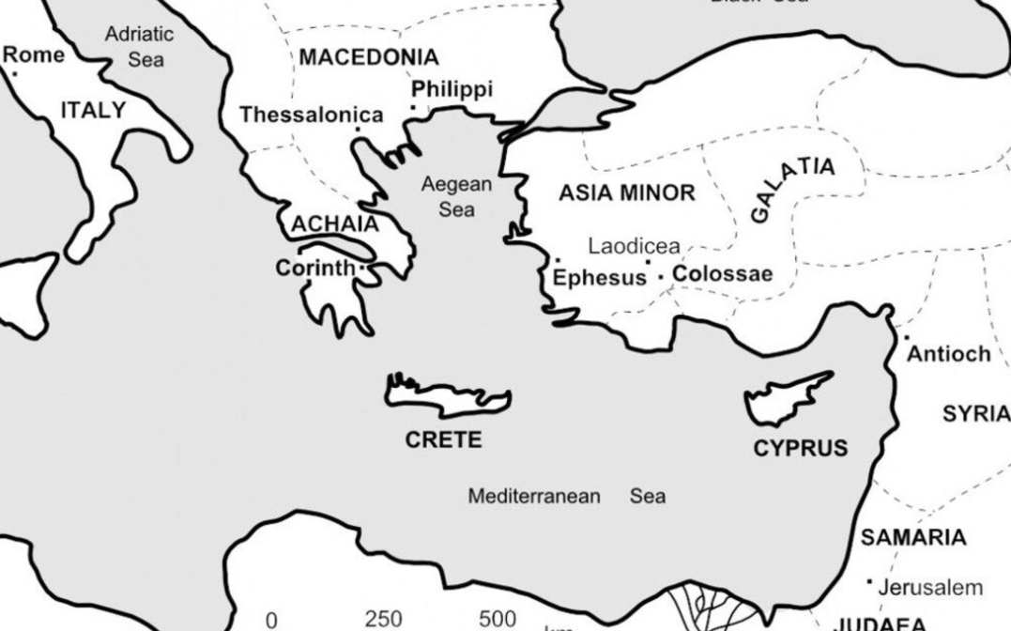
“Prayers for the Early Church”
Colossians 4:2-6
Pastor Steve Halstead
570-337-1957
hegreatermeless@gmail.com

931 East Third Street
Williamsport, Pa 17701
570-322-0091
Email: thirdstchurch931@gmail.com

